MSSV:

Họ tên SV:

Notes: Filename: HoTen_MSSV_Library.docx

**Lab09**

**Mapping**

**Exercises:**

1. Figure 7.8 shows an ER schema for a database that may be used to keep track of transport ships and their locations for maritime authorities. Map this schema into a relational schema, and specify all primary keys and foreign keys.[6 đ]

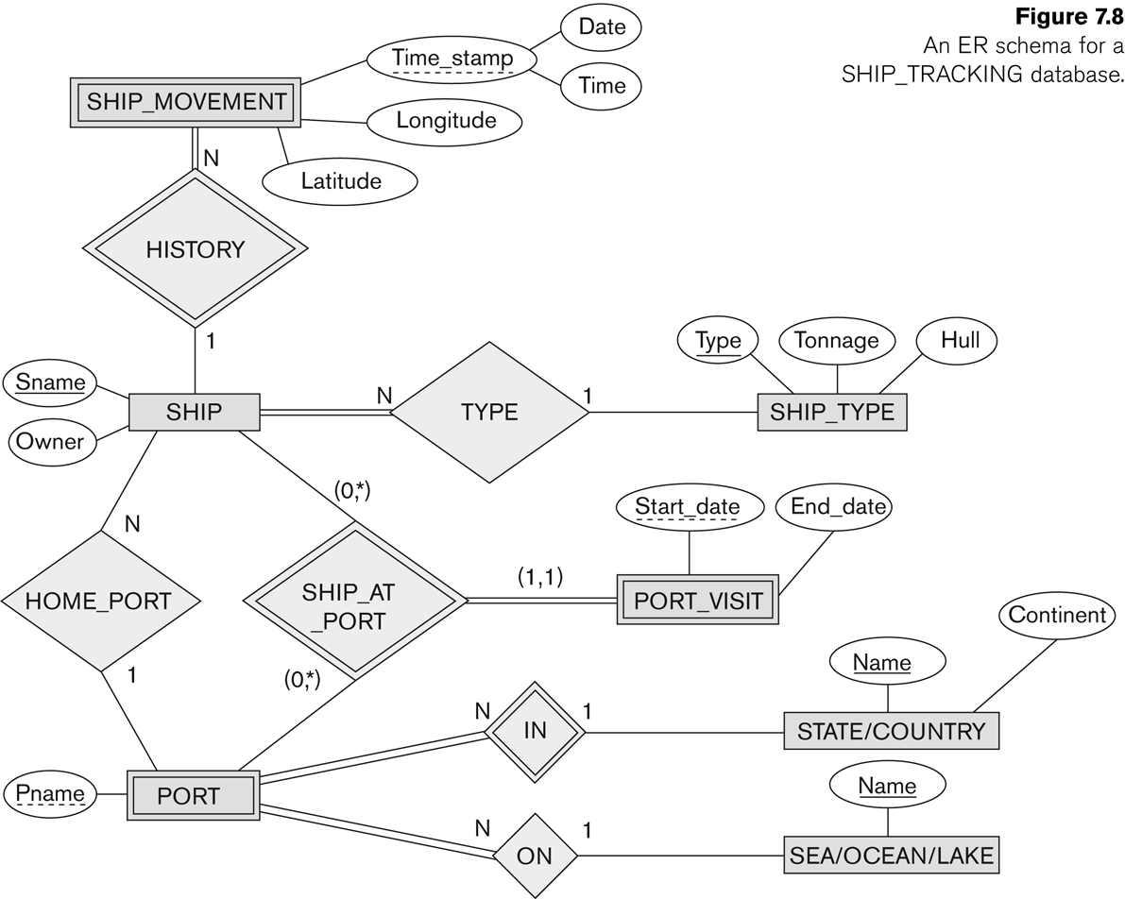

**Step By Step**Step 1: Các thực thể thông thường

a.SHIP

|  |  |
| --- | --- |
| **Sname** | Owner |

b.SHIP_TYPE

|  |  |  |
| --- | --- | --- |
| **Type** | Tonnage | Hull |

c.STATE/COUNTRY

|  |  |
| --- | --- |
| **Name** | Continent |

d. SEA/OCEAN/LAKE

|  |
| --- |
| **Name** |

Step 2: Thực thể yếu

SHIP_ MOVEMENT

|  |  |  |  |  |
| --- | --- | --- | --- | --- |
| **Sname** | Latitude | Longitude | Date | Time |

PORT_VISIT

|  |  |  |
| --- | --- | --- |
| **Sname** | Start_date | End_date |

PORT

|  |  |
| --- | --- |
| **Sname** | Pname |

Step 3: Mối quan hệ 1:1

PORT_VISIT

|  |  |  |  |  |
| --- | --- | --- | --- | --- |
| **Sname** | Owner | Start_date | End_date | SuperSname |

Step 4: Mối quan hệ 1:n

1. Mối kết hợp History

SHIP

|  |  |  |
| --- | --- | --- |
| **Sname** | Owner | Time_stamp |

1. Mối kết hợp Type

SHIP_TYPE

|  |  |  |  |
| --- | --- | --- | --- |
| **Type** | Tonnage | Hull | Sname |

1. Mối kết hợp In

STATE/COUNTRY

|  |  |  |
| --- | --- | --- |
| **Name** | Continent | Pname |

1. Mối kết hợp On

SEA/OCEAN/LAKE

|  |  |
| --- | --- |
| **Name** | Pname |

Step 5: Mối quan hệ n:n

Không có

Step 6: Thuộc tính đa trị

Không có

**Relational Diagram**

2. Map the BANK ER schema (shown in Figure 3.21) into a relational schema. Specify all primary keys and foreign keys.

Repeat for the AIRLINE schema (Figure 3.20) [2đ+2đ]

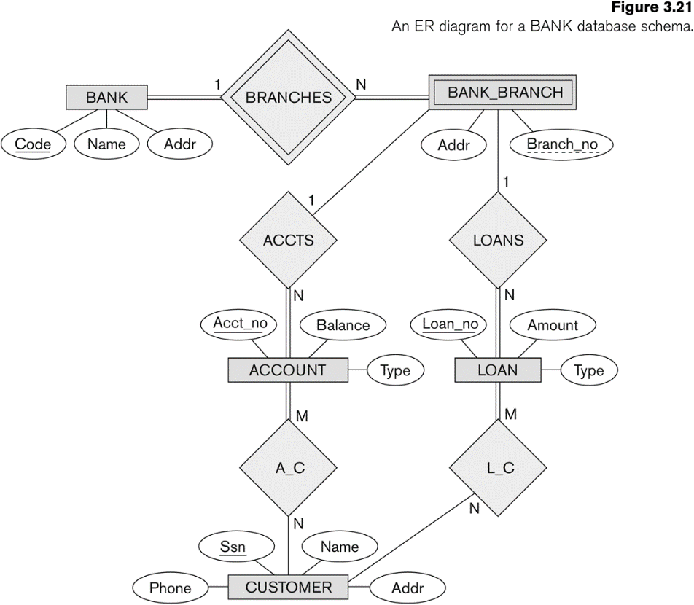

**Relational Diagram Only**

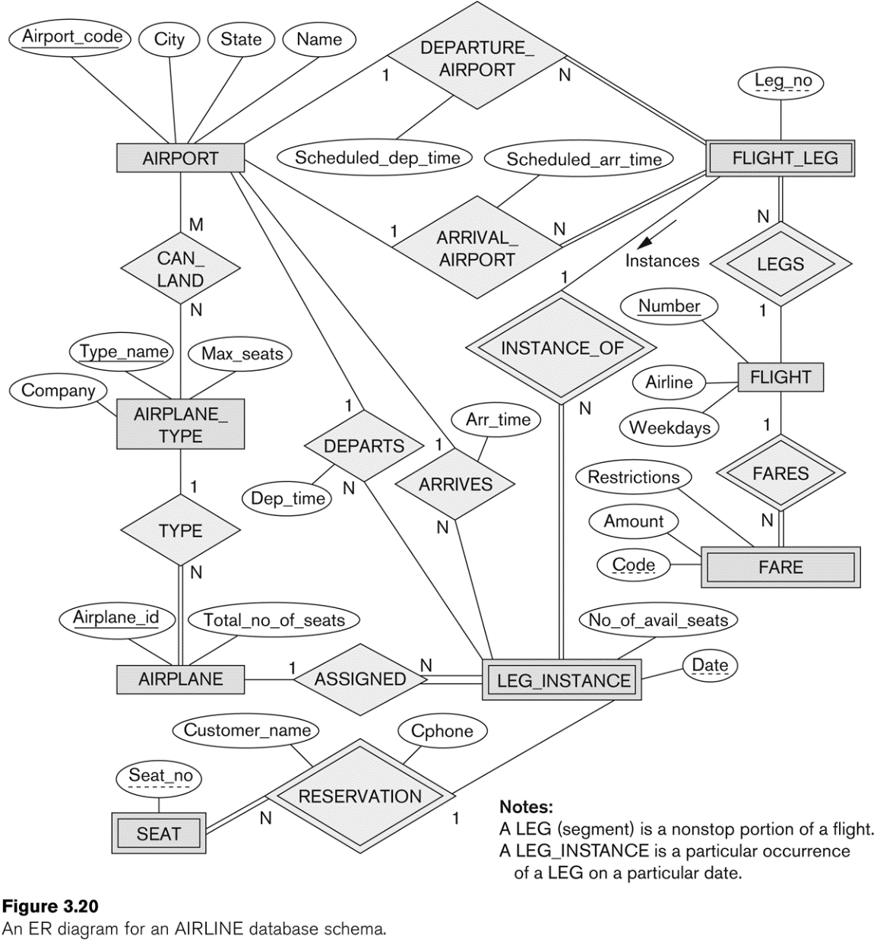

**Relational Diagram Only**

**HẾT**